Name: Sujit Kumar Datta

ID: 22201946

Section: 19

**Lab Assignment – 02**

**Task 01**

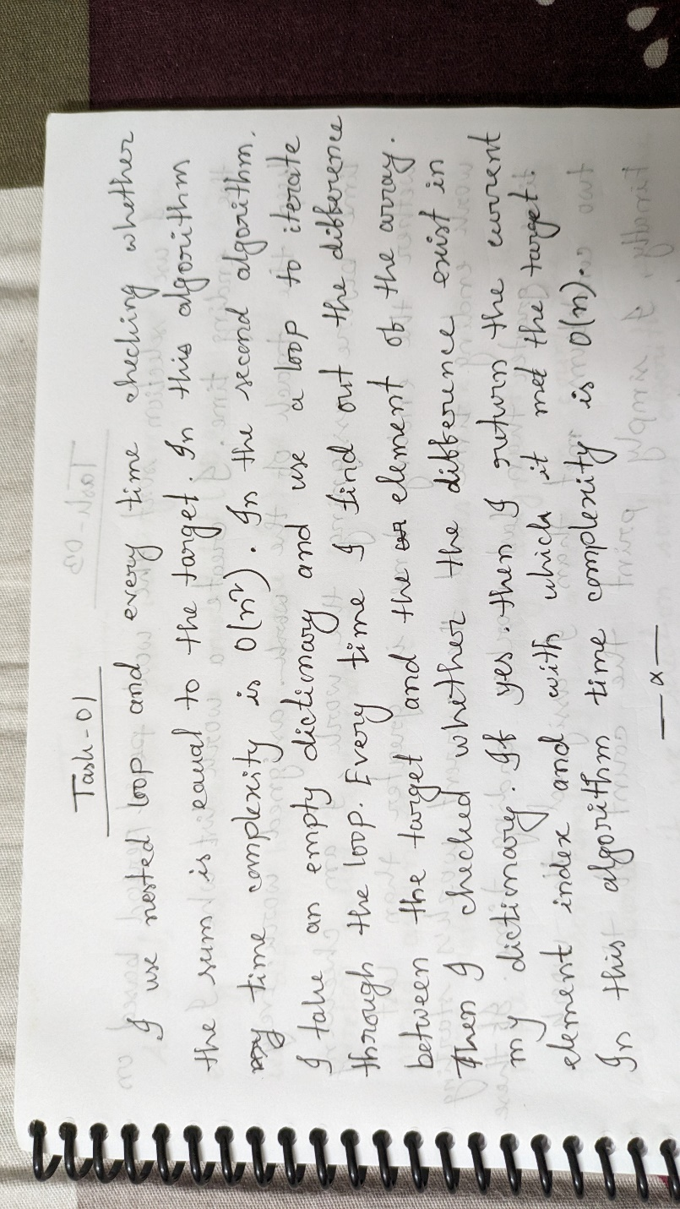

**Task 02**

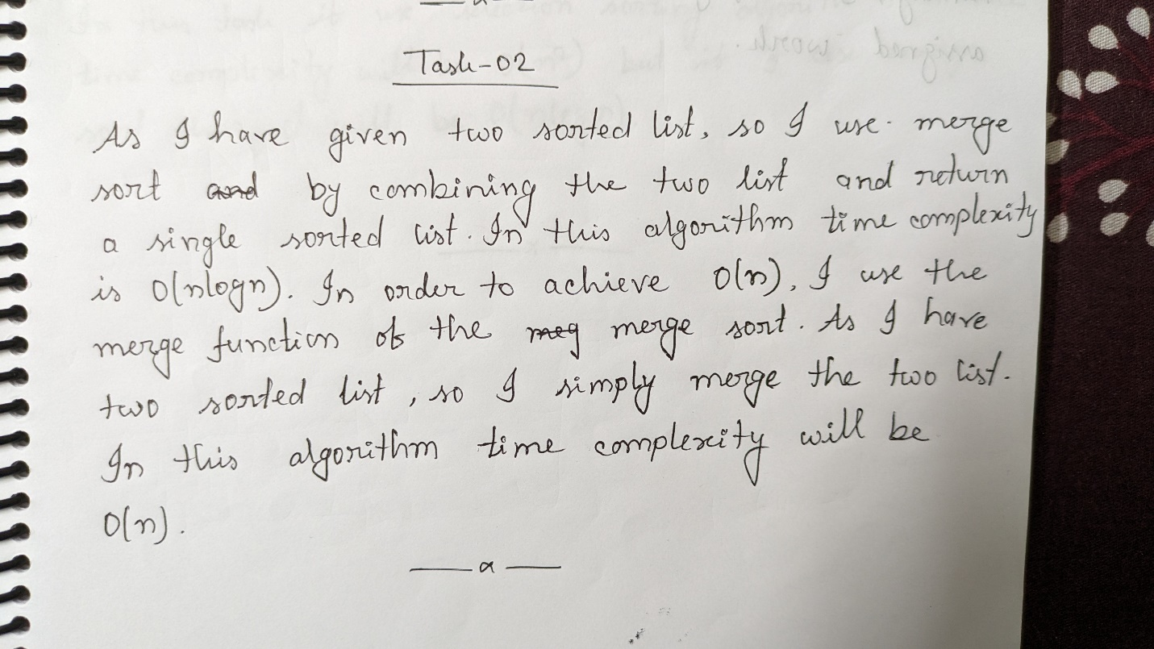

**Task 03**

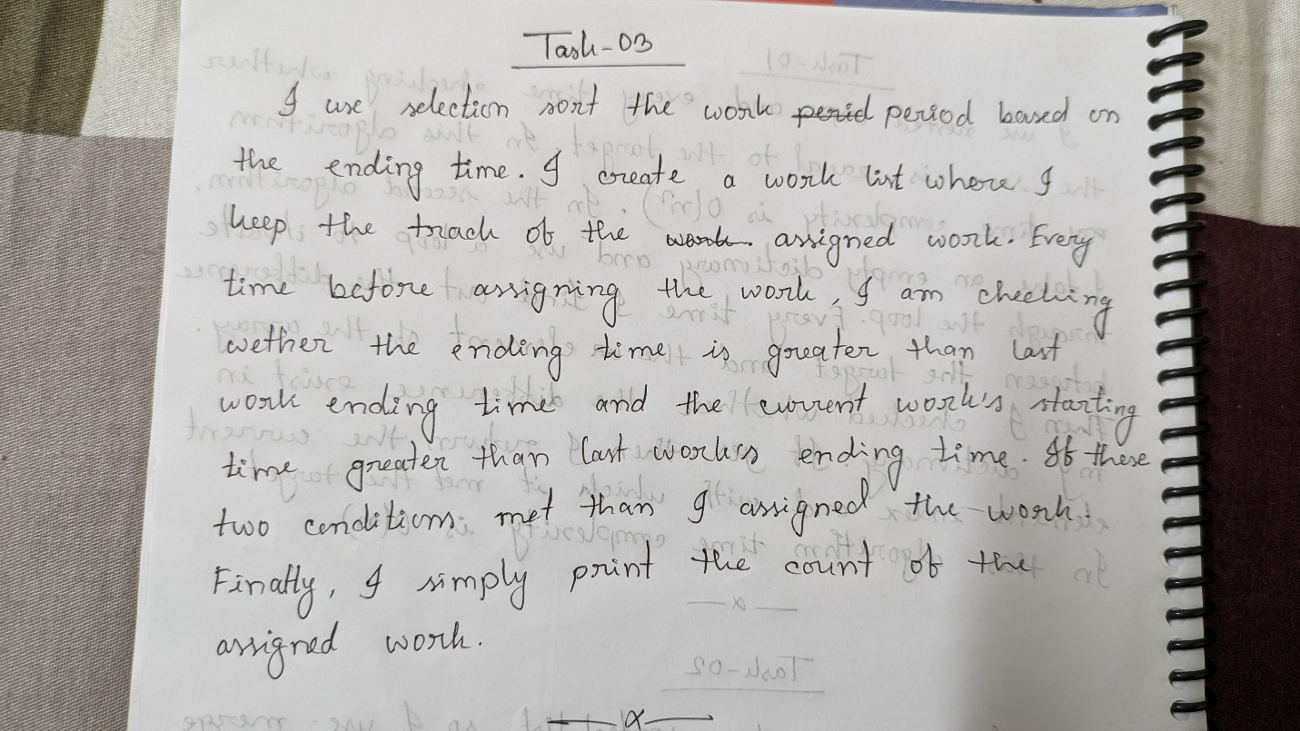

**Task 04**

